Lesson Plan Title: Pop Triptych Final Critique |  |  | Length: 45 min
Course Name | Painting | Grade Level |  | High School

Enduring Understanding(s)
Artist reference society and culture when creating a work of art.
Artists consider the role of a critic on the audience, whether good or bad.

Objectives/Learning Targets
1. Students will be able to demonstrate understanding of the characteristics and expressive features of art and design by communicating meaning through writing using correct artistic vocabulary. (Bloom’s: Creating; Standard: Comprehend; GLE: Visual art has inherent characteristics and expressive features)
2. Students will be able to relate the project to the experience of the field trip to the Andy Warhol exhibit (Bloom’s: Analyze; Standard: Transfer; GLE: Communication through advanced visual methods is a necessary skill in everyday life)&(Bloom’s: Evaluating; Standard: Comprehend; GLE: Art and design have purpose and function)
3. Students will be able to critique their own art as well as another classmates using appropriate art terminology. (Bloom’s: Analyzing; Standard: Reflect; GLE: Reflective strategies are used to understand the creative process; Interpretation is a means for understanding and evaluating works of art)

Materials
Critique sheet
Pencils
Paper
Finished Art Work
Discussion points ppt
Resources
Interpreting art worksheets (Artist’s intent, viewer’s interpretaiton, artist’s response worksheet 3 )
http://www2.cde.state.co.us/scripts/allstandards/COStandards.asp?glid=15&stid2=9&glid2=0
Pop Triptych Lesson Plan
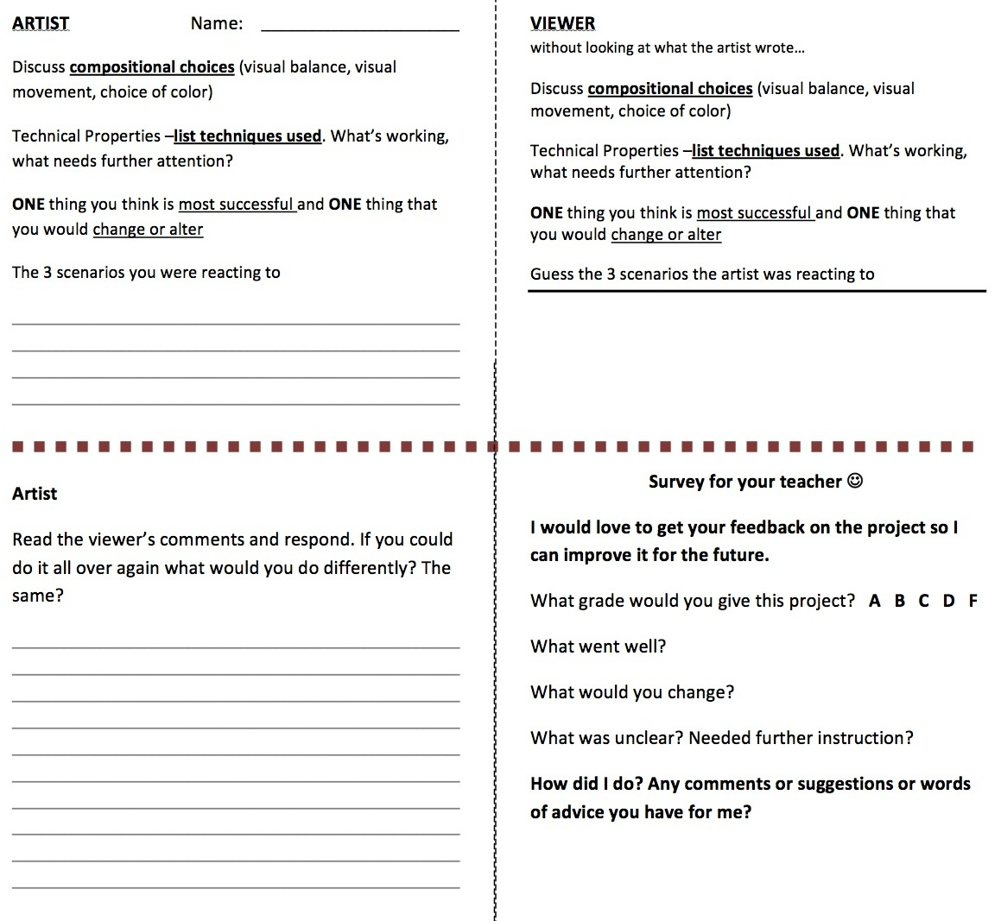
Procedures
Day 1 | Teacher | Student | Time
 | Start the class by saying thank you for everyone who attended the field trip, it was a lot of fun and you all did great! Seeing the work in person is so much different than seeing it on the projector. So again, thank you for sharing this experience with me. | Sitting quietly at desk listening to me | 2 min
1. | Have students get out their finished pop triptych self portrait  -Give them a few minutes to peel off the tape and write the scenarios they reacted to on the back of the painting… include your name!  NO painting today  In 3 minutes the only thing you will need is your painting and something to write with. | Students put finishing touches on the their piece. Take off tape, write name, write scenarios etc.  - Only thing that will be left on the desk will be their painting and something to write with. | 5 min
2. | Today we will do a critique on each of our paintings. I am passing out a worksheet to do this on.  Right now we are just going to work on the front side that says Artist Name:_______  - Write your name  - Answer the questions  - Discuss compositional choices (visual balance, visual movement, choice of color)  - Technical Properties –list techniques used. What’s working, what needs further attention?  - ONE thing you think is most successful and ONE thing that you would change or alter  - The 3 scenarios you were reacting to  Really take some time and look at your work (what would a critic say about this?)  - Use art related terminology (Like you did in your critic review)  - When you are done, fold the paper in half and put face down so that the side that says “Viewer” is facing up | Take a close look at their art and create critical judgments. Using art terminology students will be able communicate artist intent, effectiveness of material, and, what they would do differently.  -Critical thinking  -Evaluating  -Analyzing and  -Communicating using art termonology | 5 min
 | Everyone walk around the class and view everyone’s work. Then…  2. Move to another persons work, and without looking at what the artist wrote, answer the same questions.  - Discuss compositional choices (visual balance, visual movement, choice of color)  - Technical Properties –list techniques used. What’s working, what needs further attention?  - ONE thing you think is most successful and ONE thing that you would change or alter  - Guess the 3 scenarios the artist was reacting to | Students are now looking at the art of their peers. As a viewer they are creating critical judgments. Using art terminology students will be able interpret artist intent, effectiveness of material, and provide constructive criticism.  -Critical thinking  -Evaluating  -Interpreting  -Analyzing  -Communicating using art terminology | 10 min
 | 3. Go back to your painting and read the viewer’s comments. Turn the paper over and respond to if you could do it all over again what would you do differently? The same?  -I have also added a place for you to grade the overall project, starting with the watercolor calendars, warhol presentation, the project, and then the field trip. This part is not for a grade, so be honest and answer the best you can, it will help me out a lot!  - What went well?  - What would you change?  - What was unclear? Needed further instruction?  - How did I do? Any comments or suggestions or words of advice you have for me? | Carefully read the viewer’s comments and respond. Taking all things into consideration, answer: if you could do it all over again what would you do differently? The same? - Continue to use art terminology  ← Provide helpful feedback for Ms. Cibuls | 10 min
 | Debrief. . .  (Pull up questions on projector)  One person in the group needs to pull out a piece of paper. One person will be the recorder.  Discuss and write down  - Favorite part(s) of the field trip (going to the Warhol exhibit, UCA permanent collection, UCA fibers show…  - The Warhol pieces you liked the most. (When discussing this in your group, it’s ok to have a different opinion then someone else. You don’t all have to like the same one)  - Did impact (if any) did seeing the art in person have?  - Any further questions relating to Warhol, his techniques, the field trip, the project, etc...  Be prepared to have someone share your answers with the class. | Students move into groups and begin to discuss and write the 4 prompts | 15 min

Post-Assessment | Post-Assessment Instrument
Did the students...  - Demonstrate understanding of the characteristics and expressive features of art and design by communicating meaning through writing using correct artistic vocabulary.  - Critically analyze their own work of art as well as the work of others.  - Respond positively to constructive criticism.  - Relate the project to the experience of the field trip to the Andy Warhol exhibit. | 30 pts for worksheet  Artist step 1 includes (10pts)  - Compositional choices  - Technical Properties –list techniques used.  - ONE thing you think is most successful and ONE thing that you would change or alter  - The 3 scenarios you were reacting to  Artist response answers… (10 pts)  - “If you could do it all over again what would you do differently? The same?”  Viewer Response (10 pts) - completion  Teacher survey (5 pts extra credit for filling out)  15 pts for group work  - Group completion grade - did they answer the questions? did they share with the class?  Total: 50 possible points out of 45

