Pop Triptych

1. Take 5 pictures of your reaction to a popular culture scenario
Take your photos:
  - In front of a light blank wall
  - Well-lit area in direct light
  - Up close from your shoulders up
(The blank wall by the greenhouse in the hall by the drawing room works great!)
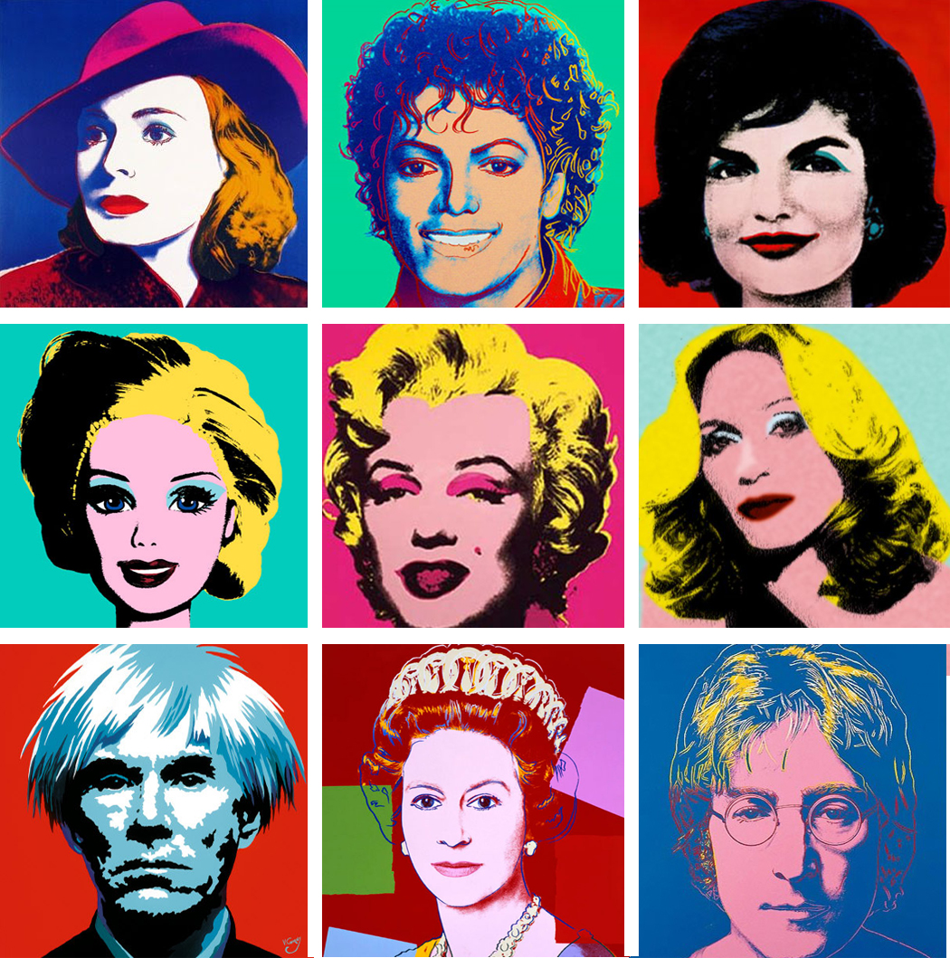
- Upload photos to student folder By Friday Feb. 7th (if you take your own)

- Chose 3 of the 5 photos
  - Remember what pop culture scenario you are reacting too

- Create a stencil of your portrait using Photoshop

- Print out the three Photoshop stencils
  - In the class folder there is a word template that the photos need to fit in.
  - Each photo will be roughly 8.5 in x 5 in

- On watercolor paper trace the triptych layout using the premade template

- Use a window or a light box to trace around the negative space of your portrait stencil
  - Draw lightly

- Use masking fluid to fill in negative space of your drawing
  - It will look funny, but when you take off the masking fluid it will look like your stencil

- Use at least one of the watercolor techniques/textures you explored in your calendar
  - Wet-on-wet / Wet-on-dry / Dry brush / Gradation / Salt / Sponge
(Other options to create texture - Splatter / Saran wrap / Lifting color / etc…)

- Write on the back of your painting which pop culture scenarios you reacted to

Things to think about:
- The order and placement of your portraits within the triptych
- Visual Balance, Visual Movement, Color, Texture, Space, and Unity.
- How with the use of color and texture you can enhance the expression shown in your portrait.

Take a close up portrait of your reaction to all of these scenarios.
You will end up picking 3 for your final piece.
Make sure to write down which ones you choose!

- You are watching the Super Bowl halftime show, and Bruno Mars doesn’t show up! Then the broncos lose
- Miley Cyrus fell off of a wrecking ball
- You are walking down the street and see a large group of people planking… Then they start doing the Harlem Shake
- Yolo
- Justin Bieber gets deported

